Project Name: Deploy Application on Cloud.

GitHub Link:

## <https://github.com/tamasjit/myjavaproject/tree/master/Phase%205/Phase-5_Practice_Project/q3_DeployApplicationonCloud>

## Output:

### Landing Page:

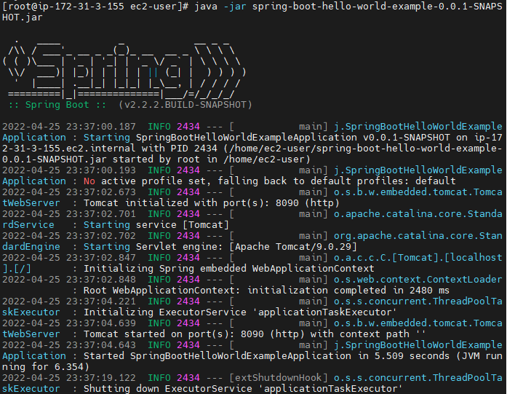

Output on the 8090 Port:

